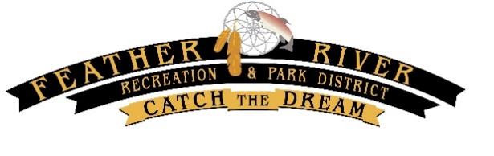

**FEATHER RIVER RECREATION & PARK DISTRICT OROVILLE CONVENTION CENTER**

Regular Board Meeting 1200 Myers Street

August 26, 2025 Oroville, CA 95965

**AGENDA                            Open Session at 5:30pm**

*Written comments must be sent to Samanthr@frrpd.com 1-hour prior to the meeting to be presented to the Board. If you need a special accommodation to participate in this meeting, please contact (530) 533-2011.*

# CALL MEETING TO ORDER

# ROLL CALL

Chairperson Greg Passmore

Vice-Chairperson Shannon DeLong

Director Devin Thomas

Director Michelle Huffman

Director Scott “Kent” Fowler

# PLEDGE OF ALLEGIANCE

# MISSION STATEMENT

**OUR MISSION:** *We will provide and maintain quality parks, recreation experiences, and related facilities and programs for all residents of the District in a fiscally sustainable manner that compliments the natural resources and cultural heritage of our community.*

# PUBLIC COMMENT

The Board will invite anyone in the audience wishing to address the Board, on a matter not listed on the agenda, to state your name for the record and make your presentation. You are limited to three (3) minutes*. The Board cannot take any action except for a brief response by the Board or staff to a statement or question relating to a non-agenda item.*

# CONSENT AGENDA

*Items listed on the Consent Agenda are considered routine and will be enacted, approved, or adopted by one motion unless a request for removal or explanation is received from a Board member, staff, or member of the public. Items removed shall be considered immediately following the adoption of the Consent Agenda.*

1. July 22, 2025 Regular Board Meeting Minutes (Appendix A)
2. July 2025 Financials (Appendix B)
3. Resolution No. 2074-25: A Resolution of the Board of Directors of the Feather River Recreation

and Park District approving a Schedule-15 Budget Amendment to Services and Supplies for FY/2024-25

(Appendix C)

1. Renewal of Oroville Union High School District (OUHSD) Facility Use Agreement 2025 – Nelson Pool (Appendix D)
2. Renewal of Butte United Soccer Club (BUSC) Facility Use Agreement 2025 – Riverbend Park (Appendix E)
3. Renewal of Las Plumas Youth Football and Cheer (LPYFC) Facility Use Agreement 2025 – Nelson Sports Complex (Appendix F)

**CONSENT AGENDA** (continued)

Motion:

Second:

Vote:

**NEW BUSINESS/ ACTION ITEMS**

# DIRECTOR & COMMITTEE REPORTS, MANAGER & STAFF REPORTS (Appendix G)

# UNFINISHED BUSINESS

1. **STAFF REPORT: HEALTH BENEFIT OPT OUT REIMBURSEMENT POLICY AND HSA CONSIDERATION**

(Appendix H)

Staff recommends the Board adopt the Health Benefit Opt-Out Reimbursement Policy as previously presented, and direct staff to evaluate the addition of an HDHP plan option.

Motion:

Vote:

# BOARD ITEMS FOR UPCOMING AGENDA(S)

# ADJOURNMENT